Group Information
Names: Fascha Aryasa, Zi Chen Zheng, Liuchang Gong, Robert Mullan
Group Number: 8

Description of Data
We will use the dataset “Customer Shopping Dataset - Retail Sales Data”, which was downloaded from website Kaggle. The dataset contains 99,457 rows and 10 columns, with each row representing an individual customer. It includes demographic information (such as age, gender) as well as shopping behavior (such as payment_method and shopping_mall). Since the dataset is publicly available, we have unlimited rights to use it.

Data Dictionary
Field Name | Description | Data Type
invoice_no | A combination of the letter 'I' and a 6-digit integer uniquely assigned to each | str
customer_id | Customer associated with that number | str
age | The age of the customer | int
gender | Gender of customer | str
category | From clothing to cosmetics or other objects | str
quantity | The quantities of each product (item) per transaction. | int
price | Unit price. Numeric. Product price per unit in Turkish Liras (TL). | float
payment_method | String variable of the payment method (cash, credit card or debit card) used for the transaction. | str
invoice_date | The day when a transaction was generated. | str
shopping_mall | The name of the shopping mall where the transaction was made. | str

Description of Situation
We will investigate consumer behavior to understand patterns in purchasing decisions, demographic influences, and preferences. The goal is to identify factors that influence customer spending and shopping frequency, which will help businesses create targeted marketing strategies.

Research Questions
- How does a customer’s age and gender affect their purchase amount?
  - Variables: age, gender, price
- Is there a relationship between customer visit frequency and their total spending?
  - Variables: customer_id, price
- Which product categories generate the highest average spending per transaction?
  - Variables: category, price
- Which payment methods and shopping malls are most associated with high-spending customers?
  - Variables: payment_method, shopping_mall, price

Deliverables

How does a customer’s age and gender affect their purchase amount?
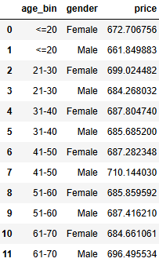
Customer age and gender were analyzed to determine whether they influence purchase amounts. A function was created to group ages into six ranges: “≤20,” “21–30,” “31–40,” “41–50,” “51–60,” and “61–70.” The data was then grouped by both age range and gender to calculate the average spending for each group. This gave a better representation of spending patterns across different demographic groups and made it easier to compare how age and gender relate to overall purchase behavior.
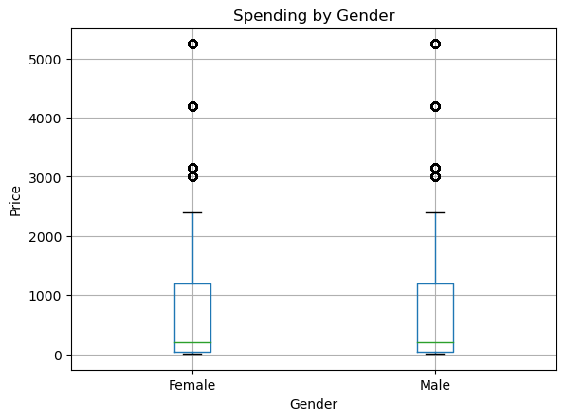
The boxplot comparing Spending by Gender shows nearly identical distributions between males and females. Both groups had a few high-spending outliers, but the median spending values are close, which suggest gender has little influence on spending.
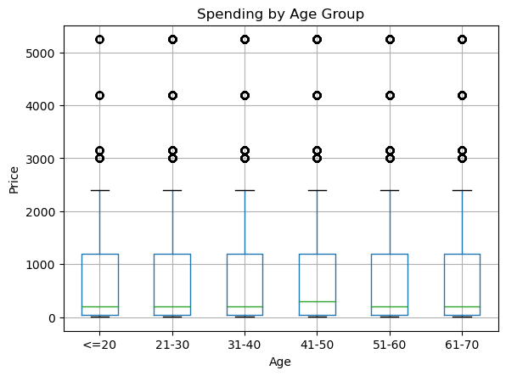
The Spending by Age Group boxplot also shows similar purchase amounts across all age categories. While there are some outliers present, the overall trend showed that age does not have a significant effect on average spending.
 | KNN | Logistic Regression
Accuracy | 0.506 | 0.527
AUC | 0.501 | 0.501
Two machine learning models, Logistic Regression and KNN, were used to predict whether a customer would be a high spender based on age and gender. Logistic Regression achieved an accuracy of 0.527, while KNN reached 0.506. Both models had the same AUC of 0.501. The small difference in accuracy and identical AUC values suggest that age and gender are weak predictors of total spending.

Overall, the binning process, grouped data, visualizations, and model results all show that customer spending patterns remain consistent across both age and gender categories.

Are there specific months or seasons where certain categories are more popular or expensive?
From the chart it seems that our top sales categories are clothing, shoes, and technology. While clothing dominates by a large margin in the sales. The data goes from January to December, but for most of the categories the sales don't change much throughout the year. At the beginning of the year the sales are dropping for clothing, shoes, and technology. I think this is happening because the holiday season just passed. I will say for the top three categories, there might be season influence with clothing sales increase during Christmas season and the summer months with the spike. While Technology and shoes seems to happen only during Christmas from the downward slope in January.
The performance of the two model are not performing well, with linear regression doing better. This could be because the model is too simple. This shows that this model is underfitting and a way to fix this is to include more features to predict from like holidays and promotions could make the predictions more accurate. Those features are not available in the dataset.
Linear regression is the better model between the two, but both model are showing signs of underfitting. The categories like clothing, shoes, and technology seems like they have better sales during December around Christmas. Clothing has a spike during the summer.

Which product categories generate the highest average spending per transaction?
Columns for analysis
- category: represents product categories such as Shoes, Technology, etc.
- price: represents spending per transaction.

The function plot_mean_spending_by_category identifies which product categories have the highest average spending per transaction. It groups the dataset by the category column, calculates the mean of the price column for each category, and sorts the results from highest to lowest average spending.

Next, the function generates a bar chart where each bar represents a product category, and its height indicates the average spending. This visualization makes it easy to compare spending patterns across categories and quickly determine which categories generate the most revenue per transaction.
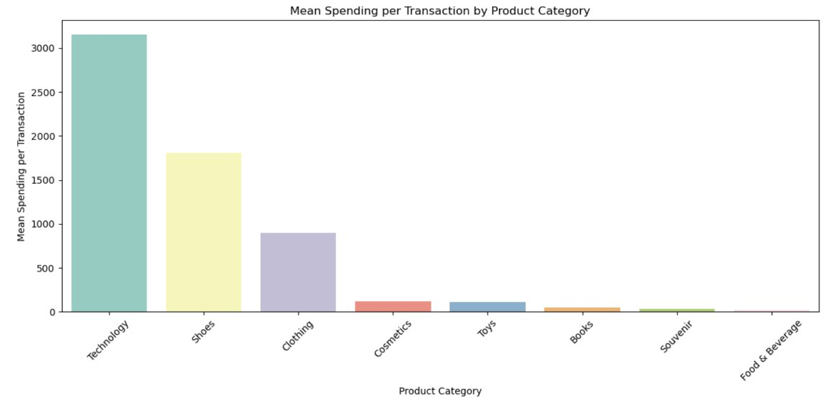
The bar chart shows the average spending per transaction across product categories. Technology leads with the highest mean spending, followed by Shoes and Clothing, while Cosmetics, Toys, Books, Souvenir, and Food & Beverage have much lower averages. The use of color differentiation makes category comparisons quick and clear, highlighting where the most revenue per transaction is generated.

Next, the plot_distribution_by_category function will explore how spending varies within each category. Unlike the bar chart, which shows averages, this function will use KDE plots to visualize the spread of transaction amounts, indicating whether spending is consistent or highly variable.

By comparing these distributions on shared axes, the visualization will reveal whether certain categories attract a few high spenders or show uniform spending patterns which will offer deeper insight into consumer behavior and revenue potential.
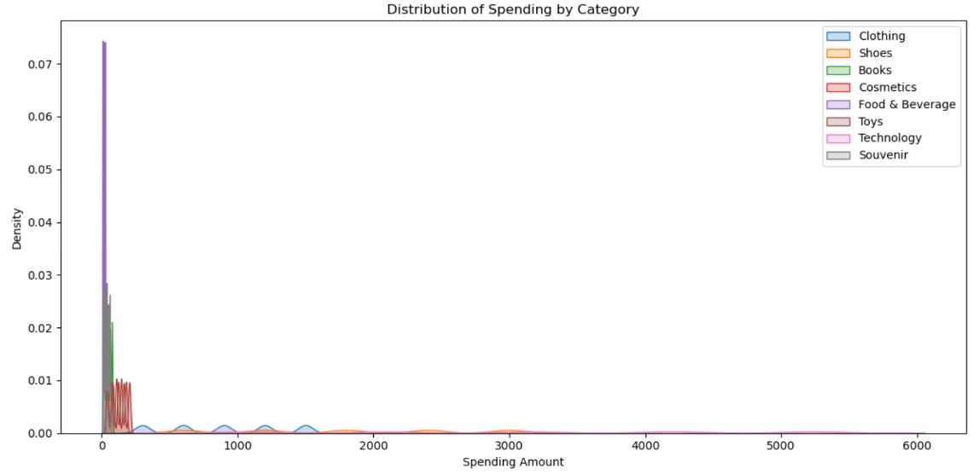
The distribution plot shows how transaction amounts vary within each product category. Categories such as Food & Beverage, Books, Cosmetics, Toys, and Souvenir have dense clusters at low spending levels, indicating that most purchases are small. In contrast, Clothing, Shoes, and especially Technology display wider distributions, reflecting higher and more variable transaction values.

The Technology category not only leads in average spending but also includes some exceptionally large purchases, driving its high mean value. Other categories remain tightly grouped around lower amounts, showing limited high-end spending.

To confirm these insights, the next step will display the top five product categories ranked by mean spending per transaction.
In conclusion, combining insights from the bar chart, distribution plot, and summary data reveals that Technology leads all categories with the highest average spending per transaction (approximately 3,157), followed by Shoes (approximately 1,807) and Clothing (approximately 901). Categories such as Cosmetics and Toys show much lower averages, typically under 150.

The distribution plots further highlight that Technology, Shoes, and Clothing not only have higher averages but also wider spending ranges, reflecting occasional high-value purchases. In contrast, lower-spending categories cluster tightly around small transaction amounts.

Key takeaway: Technology, footwear, and apparel should be targeted in order to optimize average transaction revenue because these categories attract larger and more varied purchases, which are essential information for marketing, inventory management, and revenue plans.

Which payment methods and shopping malls are most associated with high-spending customers?
I import only the three required columns, drop missing values, and exclude non-positive prices to remove obvious data issues. To obtain a robust and balanced target, I label a transaction as high spending if its price is at or above the sample median, which in my run is approximately 203.3. A median split is appropriate here because it limits the influence of outliers and yields nearly equal class sizes, which makes subsequent model metrics such as AUC and accuracy easier to interpret. 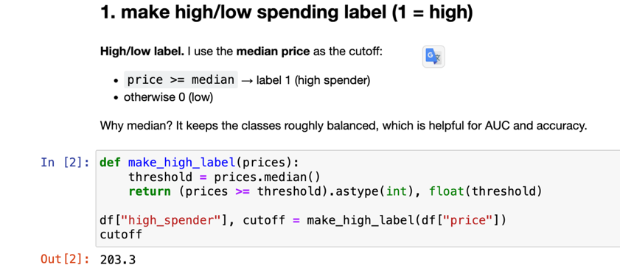
I begin with group summaries of price by payment method and by mall. On average ticket size, payment methods are nearly indistinguishable: Cash has a mean of about 690.8, Credit Card about 688.5, and Debit Card about 687.0. In contrast, malls differ more on average spend: Emaar Square Mall is highest at roughly 704.7, followed by Viaport Outlet (~694.8) and Mall of Istanbul (~694.6). Countplots then clarify the volume dimension: by simple number of transactions (and, correspondingly, the number classified as high-spending under the median rule), Mall of Istanbul—and also Kanyon—carries the heaviest traffic. This distinction matters: the countplots speak to volume, not propensity.
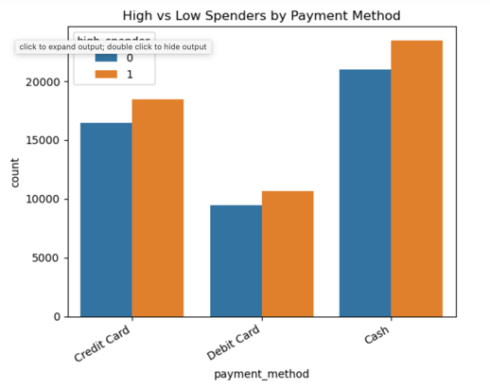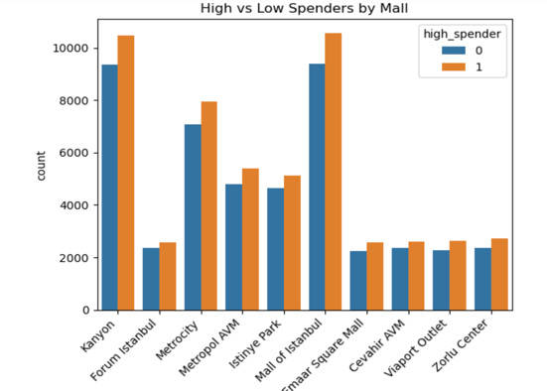
To separate propensity from volume, I construct two heatmaps over the payment×mall grid. The mean-price heatmap highlights where the average ticket is largest; the brightest cell appears at Cash × Emaar Square Mall, about 731, with Debit × Cevahir AVM (~724) and Credit × Zorlu Center (~721) also high. The second heatmap reports the high-spender rate (the mean of the binary label) and shows that malls are close in propensity, clustering around 0.52–0.54, with Emaar only slightly higher at roughly 0.55. Taken together, the results reconcile easily: Mall of Istanbul leads on volume, Emaar leads on average ticket, and the most salient payment×mall combination is Cash at Emaar (high mean and a comparatively high rate). Payment methods by themselves show only minor differences: Cash is slightly higher on average, but the three methods have very similar high/low shares.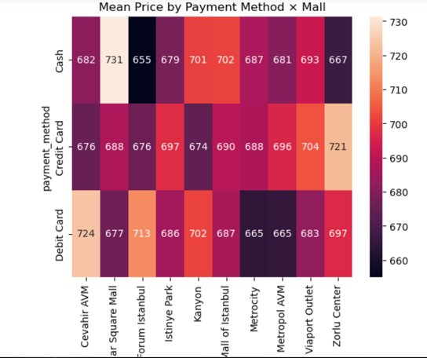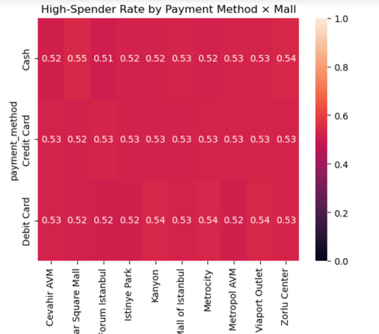
For completeness, I fit a minimal predictive baseline using only the two categorical predictors. A Linear SVM (with AUC computed from the decision function) and a Decision Tree both achieve accuracy around 0.5286 and AUC near 0.5 on the test set (SVM AUC ≈ 0.4984; Tree AUC ≈ 0.4976). ROC curves are correspondingly close to the diagonal, and confusion matrices indicate limited separability. This confirms the descriptive finding: payment method and mall are informative for segmentation (where higher spending tends to occur) but are weak standalone predictors of who will be high spending.
The main interpretive obstacle was a frequent confusion between counts and propensity: tall bars in the countplots reflect traffic, not a higher likelihood of high spending. I addressed this by explicitly adding a rate heatmap—the proportion of transactions labeled as high-spending—alongside the mean-price heatmap and by reporting results under three distinct lenses (volume, average, and rate). On the modeling side, an early attempt to compute calibrated probabilities for SVM (probability=True) was unnecessarily slow; switching to LinearSVC and using the decision function for AUC resolved the performance issue without changing the substantive conclusion. Finally, to avoid class imbalance artifacts, the median split was used for labeling, which keeps the exercise focused on associations rather than threshold tuning.

For conclusion, Emaar Square Mall is most associated with higher average spending, Mall of Istanbul is most associated with greater volume of (high label) transactions, and the clearest combination is Cash at Emaar Square Mall (highest mean and a comparatively high rate). Payment methods are otherwise very similar.

Conclusion
This project analyzed customer shopping behavior using the “Customer Shopping Dataset – Retail Sales Data” to uncover factors influencing spending patterns. Across demographic, behavioral, and categorical analyses, the results consistently indicate that individual attributes like age and gender have minimal impact on purchase amounts. Likewise, visit frequency shows no meaningful correlation with total spending.

However, product-related and contextual factors reveal stronger trends. Technology, Shoes, and Clothing categories generate the highest average spending and display greater variability, indicating opportunities for targeted marketing and inventory focus. Among shopping locations and payment methods, Emaar Square Mall stands out for higher average spending, while Mall of Istanbul leads in transaction volume. The Cash at Emaar Square Mall combination yields the highest mean spending rate, though payment methods overall show little difference.

Overall, consumer demographics offer limited predictive power for spending behavior, whereas product category and shopping context play a far more significant role in driving revenue. These insights can inform marketing strategies, mall partnerships, and pricing decisions aimed at maximizing sales potential.

